TITLE OF THE PROJECT IN UPPER CASE

Thesis submitted to
National Institute of Technology Mizoram
in partial fulfilment of the requirements for the degree

of

Master of Technology
in
Structural Engineering

by

NAME (MT2XCE0XX)

Under the guidance of

Dr. Name


Department of Civil Engineering
National Institute of Technology Mizoram
Chaltlang, Aizawl-796012, Mizoram, India

Year

This page is left blank intentionally


Department of Civil Engineering
National Institute of Technology Mizoram

DECLARATION

I______________________________________hereby declare that this project work titled “______________________________________________________” is carried out by me in the Department of Civil Engineering of National Institute of Technology Mizoram. The work is original and has not been submitted earlier whole or in part for the award of any degree/diploma at this or any other Institution/University.

Date:

Enrollment No. | Name | Signature
MT2XCE0XX | Xyz

This page is left blank intentionally

CERTIFICATE

This is to certify that the project titled “__________________________________________”, submitted by Xyz1 in partial fulfilment of the requirements for the award of the degree of Master of Technology in Structural Engineering, NIT Mizoram. The work is comprehensive, complete and fit for final submission.

Date:

Name of the Supervisor
Designation
Department of Civil Engineering
National Institute of Technology Mizoram

Name of the Head
Head of Department
Department of Civil Engineering
National Institute of Technology Mizoram

This page is left blank intentionally

ACKNOWLEDGMENTS

All acknowledgements to be included here. Please restrict to two pages only. The name of the candidate shall appear at the end, without signature.
I extend my sincere thanks to one and all of NIT Mizoram family for the completion of this document on the project report format guidelines.

Name of the Candidate

This page is left blank intentionally

CONTENTS

DESCRIPTION | PAGE NUMBER
DECLARATION | iii
CERTIFICATE | v
ACKNOWLEDGEMENT | vii
CONTENTS | ix
LIST OF FIGURES | xi
LIST OF TABLES | xiii
ABSTRACT | xv
- TITLE OF CHAPTER 1
- Section heading name | 1
- Section heading name | 1
- Second level section heading name | 1
- Second level section heading name | 3
  - Section heading name
- TITLE OF CHAPTER 2
  - Section heading name
    - Second level section heading name
REFERENCES | 5

This page is left blank intentionally

LIST OF FIGURES

FIGURE | TITLE | PAGE NUMBER
1.1 | A CNN network example using raw acceleration input data [1]. Input data can be reshaped in 1D or higher dimension vector fashion. | 3
1.2
2.1
3.1
3.2
3.3

This page is left blank intentionally

LIST OF TABLES

TABLE | TITLE | PAGE NUMBER
1.1 | Comparison of Traditional Methods vs. AI Techniques. | 3
1.2
2.1
3.1
3.2
3.3

This page is left blank intentionally

ABSTRACT

Abstract of the report to be given here. Please restrict to a maximum of 300 words. NOTE: The abstract should not have any citations, or abbreviations, nor should it be divided into sections. It can be divided into adequate number of paragraphs as the student wishes. It is advisable to avoid any equations in the Abstract. Figures and tables are to be avoided.
The text in the report should be in Times New Roman, font size 12, single-column. Vertical spacing should be restricted to 1.5 lines. Figure captions should be centered, while table captions should be right-aligned. All content should be justified. Page numbering before Chapter 1 should be in Roman numerals. Referencing must follow the APA style. Students must strictly adhere to this template.

This page is left blank intentionally

CHAPTER 1
INTRODUCTION

The field of civil engineering has witnessed significant advancements due to the integration of artificial intelligence. AI, also known as enhanced intelligence, leverages machines to perform tasks intelligently, efficiently, and effectively. Let’s explore how AI is transforming the civil engineering landscape:
- Challenges in Traditional Approaches
Traditional methods for modelling and optimizing building and engineering networks require massive computational power. AI-based technologies offer promising solutions to address these challenges.
- Applications of AI in Civil Engineering
  - Construction Management
    - Deep Learning: This technology has been effectively used in various industries, including construction management. Complex systems like skyscrapers have driven the adoption of machine learning techniques.
    - Efficiency Boost: AI algorithms, big data, and deep learning have revolutionized production efficiency in the construction sector. Contractors, network operators, and civil engineers use AI to tackle various issues.
  - Design Optimization and Risk Management
    - Early-Stage Optimization: AI is employed at the beginning of projects to optimize designs, manage risks, and enhance overall output.
    - Profitability: Companies implementing AI practices in development are reportedly 50% more profitable.
- AI Specializations in Civil Engineering
Various branches of AI find applications in civil engineering:
Machine Learning
Deep Learning
Fuzzy Logic
Pattern Recognition
Decision Trees
Swarm Optimization

This page is left blank intentionally

These AI techniques empower engineers to make better decisions and achieve greater efficiency. As we continue to witness advancements, AI will play an increasingly vital role in shaping the future of civil engineering.

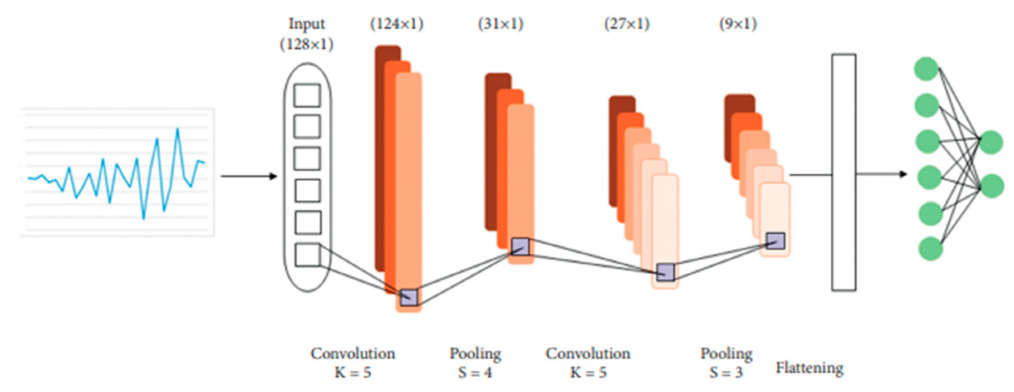
Fig. 1. A CNN network example using raw acceleration input data [1]. Input data can be reshaped in 1D or higher dimension vector fashion.

Table 1. Comparison of Traditional Methods vs. AI Techniques.
Aspect | Traditional Methods | AI Techniques
Computational Efficiency | High | Very High
Decision-Making Accuracy | Moderate | High
Risk Management | Manual | Automated
Design Optimization | Iterative | Early-Stage

This page is left blank intentionally

REFERENCES

- Chamangard, M., Ghodrati Amiri, G., Darvishan, E., & Rastin, Z. (2022). Transfer learning for CNN-based damage detection in civil structures with insufficient data. Shock and Vibration, 2022, 3635116.
- Yadav, A., Amabili, M., Panda, S. K., Dey, T., & Kumar, R. (2021). Forced nonlinear vibrations of circular cylindrical sandwich shells with cellular core using higher-order shear and thickness deformation theory. Journal of Sound and Vibration, 510, 116283.
- Yadav, A., Amabili, M., Panda, S. K., Dey, T., & Kumar, R. (2021). Nonlinear damped vibrations of three-phase CNT-FRC circular cylindrical shell. Composite Structures, 255, 112939.

